Chapter 8

Risk Management: Assessing and Controlling Risk

Chapter Overview
The eighth chapter of the text presents essential risk mitigation strategy options and opens the discussion of how to control risk. This will include identifying risk control classification categories, using existing conceptual frameworks to evaluate risk controls, and formulating a cost benefit analysis. Readers will learn how to maintain and perpetuate risk controls. As a method to contrast the approach presented in the earlier parts of the chapter, the OCTAVE approach to managing risk is introduced.

Chapter Objectives
When you complete this chapter, you will be able to:
- Understand and select from the risk mitigation strategy options to control risk
- Identify the risk control classification categories
- Use existing conceptual frameworks to evaluate risk controls, and formulate a cost benefit analysis
- Maintain and perpetuate risk controls
- Understand the OCTAVE approach to managing risk, and locate more detailed information about it if and when necessary

Set-up Notes
This chapter could be completed in a single class session, if there is sufficient time to cover the material. Unless the students have not had the opportunity to read the material in advance (in some settings, the textbooks are not made available until the first class meeting), it may be prudent to have a general discussion of the topic, with detailed lecture to follow at the next class meeting. The subject matter can be covered in 1.25 to 2.5 hours.

Lecture Notes and Teaching Tips with Quick Quizzes
Introduction
To keep up with the competition, organizations must design and create a safe environment in which business processes and procedures can function.
This environment must maintain confidentiality and privacy and assure the integrity and availability of organizational data.
These objectives are met via the application of the principles of risk management.
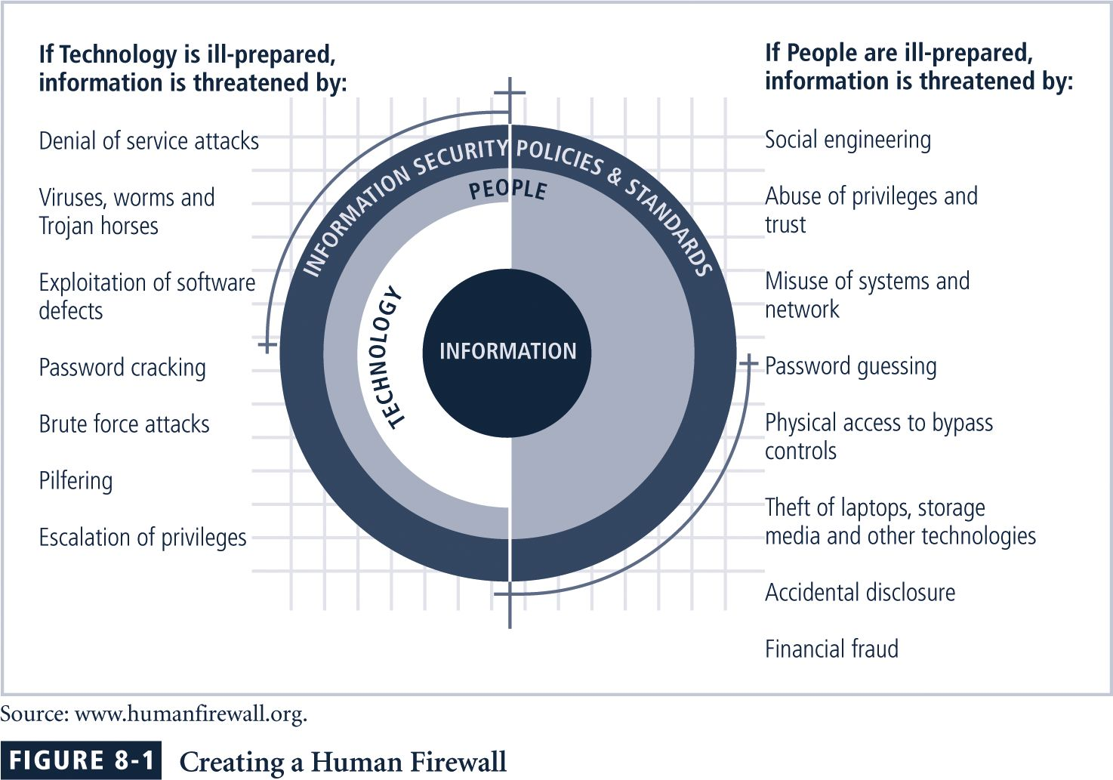

Quick Quiz
- What are the main responsibilities of a proper business environment? ANSWER: This environment must maintain confidentiality and privacy and assure the integrity and availability of organizational data.

Risk Control Strategies
An organization must choose one of four basic strategies to control risks:
- Avoidance: applying safeguards that eliminate or reduce the remaining uncontrolled risks for the vulnerability
- Transference: shifting the risk to other areas or to outside entities
- Mitigation: reducing the impact should the vulnerability be exploited
- Acceptance: understanding the consequences and accept the risk without control or mitigation
Avoidance
Avoidance is the risk control strategy that attempts to prevent the exploitation of the vulnerability.
Avoidance is accomplished through:
- Application of policy
- Application of training and education
- Countering threats
- Implementation of technical security controls and safeguards
Transference
Transference is the control approach that attempts to shift the risk to other assets, other processes, or other organizations.
This may be accomplished by rethinking how services are offered, revising deployment models, outsourcing to other organizations, purchasing insurance, or by implementing service contracts with providers.
Mitigation
Mitigation is the control approach that attempts to reduce, by means of planning and preparation, the damage caused by the exploitation of vulnerability.
This approach includes three types of plans:
- the disaster recovery plan (DRP),
- incident response plan (IRP), and
- business continuity plan (BCP).
Mitigation depends upon the ability to detect and respond to an attack as quickly as possible.
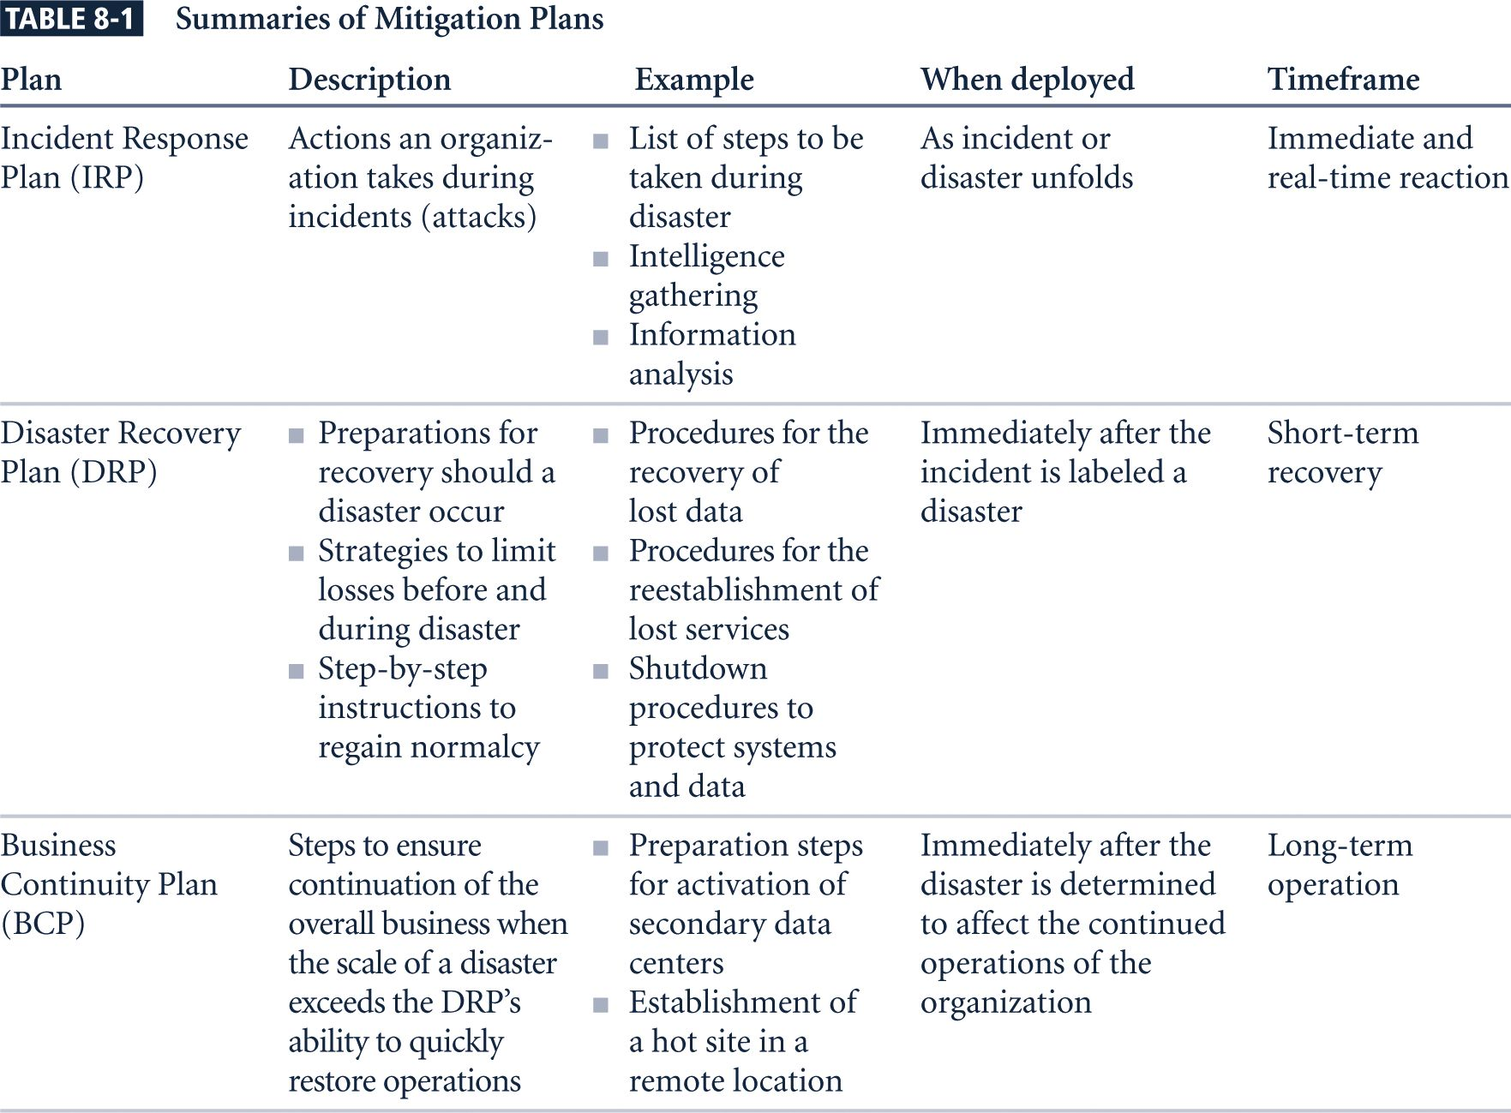
Acceptance
As described above, mitigation is a control approach that attempts to reduce the impact of an exploited vulnerability.
In contrast, acceptance of risk is the choice to do nothing to protect an information asset and to accept the outcome from any resulting exploitation.
This control, or lack of control, assumes that it may be a prudent business decision to examine the alternatives and conclude that the cost of protecting an asset does not justify the security expenditure.
The only valid use of the acceptance strategy occurs when the organization has:
- Determined the level of risk to the information asset
- Assessed the probability of attack and the likelihood of a successful exploitation of a vulnerability
- Approximated the ARO of the exploit
- Estimated the potential loss from attacks
- Performed a thorough cost benefit analysis
- Evaluated controls using each appropriate type of feasibility
- Decided that the particular asset did not justify the cost of protection

Quick Quiz
- What are the four basic strategies available for controlling risk? ANSWER: Avoidance: applying safeguards that eliminate or reduce the remaining uncontrolled risks for the vulnerability, Transference: shifting the risk to other areas or to outside entities, Mitigation: reducing the impact should the vulnerability be exploited, Acceptance: understanding the consequences and accept the risk without control or mitigations.

Risk Control Strategy Selection
Risk control involves selecting one of the four risk control strategies for the vulnerabilities present within the organization.
If the loss is within the range of losses the organization can absorb, or if the attacker’s gain is less than expected costs of the attack, the organization may choose to accept the risk.
Otherwise, one of the other control strategies will have to be selected.
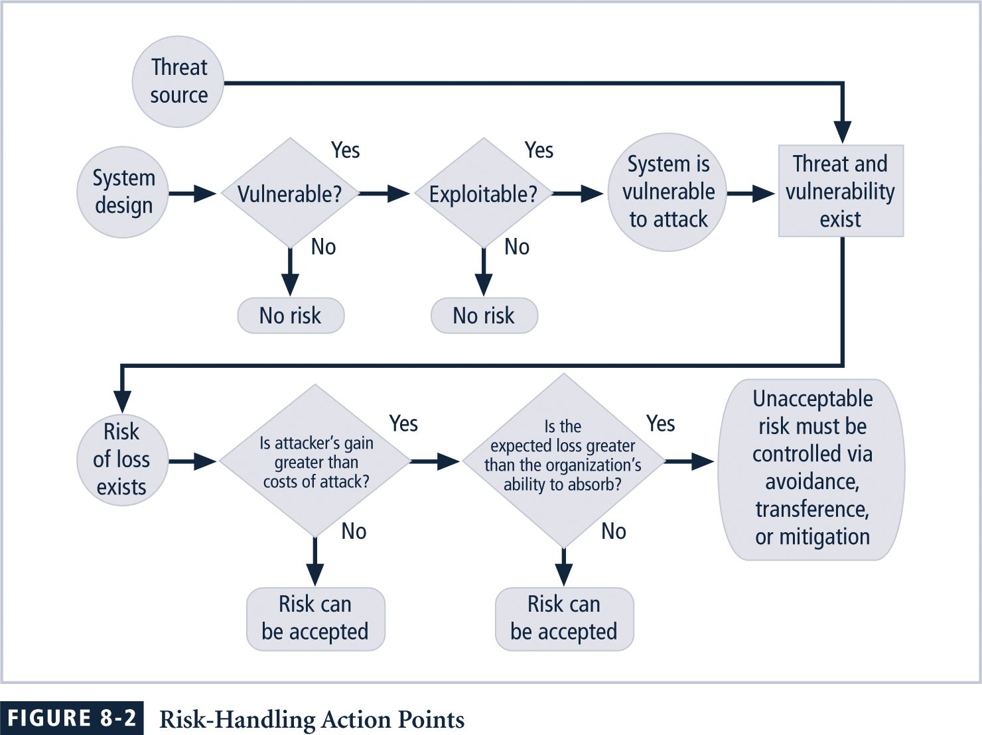
Some rules of thumb on strategy selection are:
- When a vulnerability exists: Implement security controls to reduce the likelihood of a vulnerability being exercised.
- When a vulnerability can be exploited: Apply layered controls to minimize the risk or prevent occurrence.
- When the attacker’s potential gain is greater than the costs of attack: Apply protections to increase the attacker’s cost, or reduce the attacker’s gain, using technical or managerial controls.
- When potential loss is substantial: Apply design controls to limit the extent of the attack, thereby reducing the potential for loss.
Evaluation, Assessment, and Maintenance of Risk Controls
Once a control strategy has been selected and implemented, the effectiveness of controls should be monitored and measured on an ongoing basis to determine its effectiveness and the accuracy of the estimate of the risk that will remain after all planned controls are in place.
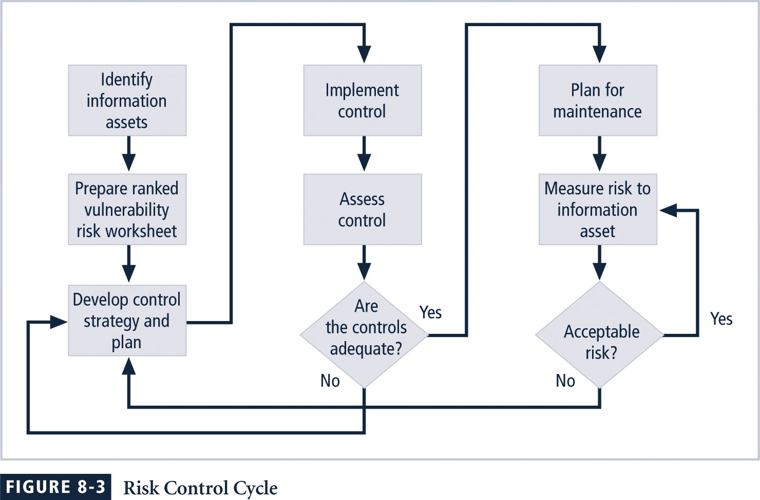

Quick Quiz
- What is risk avoidance? ANSWER: Risk avoidance attempts to prevent the exploitation of the vulnerability.

Categories of Controls
Controlling risk by means of avoidance, mitigation, or transference may be accomplished by implementing controls or safeguards. Controls can be placed into one of four categories:
- Control function
- Architectural layer
- Strategy layer
- Information security principle

Control Function
Controls designed to defend a vulnerable system are either preventive or detective.
Preventive controls stop attempts to exploit a vulnerability by implementing enforcement of an organizational policy or a security principle and use a technical procedure, or some combination of technical means and enforcement methods.
Detective controls warn organizations of violations of security principles, organizational policies, or attempts to exploit vulnerabilities and use techniques such as audit trails, intrusion detection, and configuration monitoring.
Architectural Layer
Some controls apply to one or more layers of an organization’s technical architecture. Possible architectural layering models may include the following:
- Organizational policy
- External networks
- Extranets
- Demilitarized zones
- Intranets
- Network devices that interface network zones
- Systems
- Applications
Strategy Layer
Controls are sometimes classified by the risk control strategy they operate within: avoidance, mitigation, or transference.
Note that the acceptance strategy is not an option since it involves the absence of controls.
Information Security Principle
Risk controls operate within one or more of the commonly accepted information security principles:
- Confidentiality
- Integrity
- Availability
- Authentication
- Authorization
- Accountability
- Privacy

Quick Quiz
- What are the names of the categories in which controls can be placed? ANSWER: Control function, Architectural layer, Strategy layer, Information security principle.

Feasibility Studies and Cost Benefit Analysis
Before deciding on the strategy for a specific vulnerability, all readily accessible information about the consequences of the vulnerability must be explored.
“What are the advantages of implementing a control as opposed to the disadvantages of implementing the control?”
There are a number of ways to determine the advantage or disadvantage of a specific control.
The primary means is to determine the value of the information assets that it is designed to protect.
Cost Benefit Analysis (CBA)
The criterion most commonly used when evaluating a project that implements information security controls and safeguards is economic feasibility.
Organizations are urged to begin a cost benefit analysis by evaluating the worth of the information assets to be protected and the loss in value if those information assets are compromised by the exploitation of a specific vulnerability.
This decision-making process is called a cost benefit analysis or an economic feasibility study.
Cost
Just as it is difficult to determine the value of information, it is difficult to determine the cost of safeguarding it.
Some of the items that affect the cost of a control or safeguard include:
- Cost of development or acquisition of hardware, software, and services
- Training fees
- Cost of implementation
- Service costs
- Cost of maintenance
Benefit
Benefit is the value to the organization of using controls to prevent losses associated with a specific vulnerability.
The benefit is usually determined by valuing the information asset or assets exposed by the vulnerability and then determining how much of that value is at risk and how much risk there is for the asset.
This is expressed as the annualized loss expectancy (ALE).
Asset Valuation
Asset valuation is the process of assigning financial value or worth to each information asset.
The value of information differs within organizations and between organizations, based on the characteristics of information and the perceived value of that information.
The valuation of assets involves estimation of real and perceived costs associated with the design, development, installation, maintenance, protection, recovery, and defense against loss and litigation.
Some of the components of asset valuation include:
- Value retained from the cost of creating the information asset
- Value retained from past maintenance of the information asset
- Value implied by the cost of replacing the information
- Value from providing the information
- Value acquired from the cost of protecting the information
- Value to owners
- Value of intellectual property
- Value to adversaries
- Loss of productivity while the information assets are unavailable
- Loss of revenue while information assets are unavailable
An organization must be able to place a dollar value on each collection of information and the information assets it owns, based on:
- How much did it cost to create or acquire this information?
- How much would it cost to recreate or recover this information?
- How much does it cost to maintain this information?
- How much is this information worth to the organization?
- How much is this information worth to the competition?
Next the organization examines the potential loss that could occur from the exploitation of vulnerability or a threat occurrence.
This process results in the estimate of potential loss per risk.
The questions that must be asked here include:
- What damage could occur, and what financial impact would it have?
- What would it cost to recover from the attack, in addition to the financial impact of damage?
- What is the single loss expectancy for each risk?
A single loss expectancy, or SLE, is the calculation of the value associated with the most likely loss from an attack.
It is a calculation based on the value of the asset and the expected percentage of loss that would occur from a particular attack:
SLE = asset value (AV) x exposure factor (EF)
Where EF = the percentage loss that would occur from a given vulnerability being exploited.
This information is usually estimated.
In most cases, the probability of a threat occurring is usually a loosely derived table indicating the probability of an attack from each threat type within a given time frame.
This value is commonly referred to as the ARO, or annualized rate of occurrence.
In order to standardize calculations, you convert the rate to a yearly (annualized) value.
This is expressed as the probability of a threat occurrence.
Once each asset’s worth is known, the next step is to ascertain how much loss is expected from a single attack, and how often these attacks occur.
Once those values are determined, the equation can be completed to determine the overall lost potential per risk.
This is usually determined via an annualized loss expectancy, or ALE, using the values for the ARO and SLE from previous sections.
ALE = SLE x ARO
The Cost Benefit Analysis (CBA) Formula
CBA determines whether or not a control alternative is worth its associated cost.
CBAs may be calculated before a control or safeguard is implemented, to determine if the control is worth implementing, or calculated after controls have been implemented and have been functioning for a time.
CBA = ALE(prior) – ALE(post) – ACS
ALE(prior to control) is the annualized loss expectancy of the risk before the implementation of the control.
ALE(post control) is the ALE examined after the control has been in place for a period of time.
ACS is the annual cost of the safeguard.
Other Feasibility Studies
In the previous sections the concepts of economic feasibility or using baselines or benchmarks were used to justify proposals for information security controls.
The next step in measuring how ready an organization is for these controls is determining the proposal’s organizational, operational, technical, and political feasibility.
Organizational feasibility analysis examines how well the proposed information security alternatives will contribute to the operation of an organization.
Operational feasibility addresses user acceptance and support, management acceptance and support, and the overall requirements of the organization’s stakeholders.
Technical feasibility examines whether or not the organization has or can acquire the technology to implement and support the alternatives.
Political feasibility defines what can and cannot occur based on the consensus and relationships between the communities of interest.
Benchmarking
Benchmarking is the process of seeking out and studying the practices used in other organizations that produce the results you desire in your organization.
An organization typically benchmarks by selecting a measure with which to compare itself with the other organizations in its market.
The organization then measures the difference in the way it conducts business and the way the other organizations conduct business.
When benchmarking, an organization typically uses one of two measures to compare practices: metrics-based measures or process-based measures.
Metrics-based measures are comparisons based on numerical standards, such as:
- Numbers of successful attacks
- Staff hours spent on systems protection
- Dollars spent on protection
- Numbers of security personnel
- Estimated value in dollars of the information lost in successful attacks
- Loss in productivity hours associated with successful attacks
Process-based measures are generally less focused on numbers and are more strategic.
For each of the areas the organization is interested in benchmarking, process based measures enable the companies to examine the activities an individual company performs in pursuit of its goal, rather than the specifics of how goals are attained.
The primary focus is the method the organization uses to accomplish a particular process, rather than the outcome.
In the field of information security, two categories of benchmarks are used:
- standards of due care and due diligence, and
- best practices.
Within best practices, the gold standard is a subcategory of practices that are typically viewed as “the best of the best.”
Due Care and Due Diligence
For legal reasons, an organization may be forced to adopt a certain minimum level of security.
When organizations adopt levels of security for a legal defense, they may need to show that they have done what any prudent organization would do in similar circumstances. This is referred to as a standard of due care.
Due diligence is the demonstration that the organization is persistent in ensuring that the implemented standards continue to provide the required level of protection.
Best Business Practices.
Security efforts that seek to provide a superior level of performance are referred to as best business practices.
Best security practices are those that are among the best in the industry, balancing access to information with adequate protection, while maintaining a solid degree of fiscal responsibility.
Companies with best practices may not be the best in every area, but may simply have established an extremely high quality or successful security effort in one or more area.
The Gold Standard
Even the best business practices are not sufficient for some organizations. These organizations aspire to set the standard by implementing the most protective, supportive, and yet fiscally responsible standards they can.
The gold standard is a defining level of performance that demonstrates a company’s industrial leadership, quality, and concern for the protection of information.
Seeking the gold standard is a method of striving for excellence.
Applying Best Practices
When considering best practices for adoption, address the following questions:
- Does your organization resemble the organization that is implementing the best practice under consideration?
- Is your organization in a similar industry?
- Does your organization face similar challenges?
- Is your organizational structure similar to the organization from which you are modeling the best practices?
- Can your organization expend resources that are in line with the requirements of the best practice?
- Is your organization in a similar threat environment as the one cited in the best practice?
Problems with Benchmarking and Best Practices
- Organizations don’t talk to each other.
- No two organizations are identical.
- Best practices are a moving target.
- Simply knowing what was going on a few years ago, doesn’t necessarily indicate what to do next.
Baselining
Baselining is the analysis of measures against established standards.
In information security, baselining is the comparison of security activities and events against the organization’s future performance.
The information gathered for an organization’s first risk assessment becomes the baseline for future comparisons.

Quick Quiz
- What is cost benefit analysis? ANSWER: The criterion most commonly used when evaluating a project that implements information security controls and safeguards is economic feasibility.

Risk Management Discussion Points
Risk Appetite
Risk appetite defines the quantity and nature of risk that organizations are willing to accept, as they evaluate the trade-offs between perfect security and unlimited accessibility.
The reasoned approach to risk is one that balances the expense against the possible losses if exploited.
Residual Risk
When vulnerabilities have been controlled as much as possible, there is often remaining risk that has not been completely removed, shifted, or planned for.
This remainder is called residual risk.
“Residual Risk is a combined function of (1) a threat less the effect of threat-reducing safeguards; (2) a vulnerability less the effect of vulnerability-reducing safeguards, and (3) an asset less the effect of asset value-reducing safeguards.”
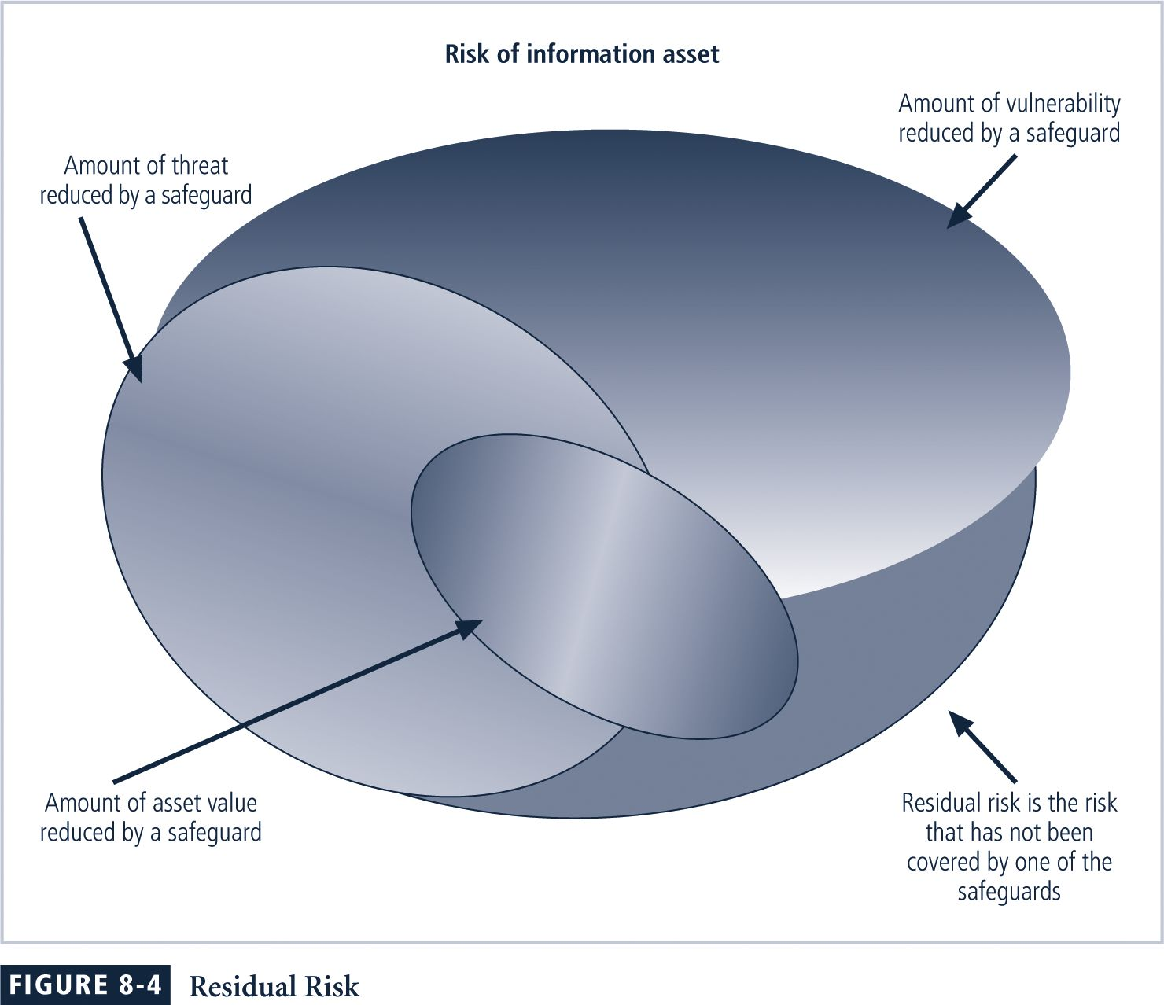
The significance of residual risk must be judged within the context of an organization.
The goal of information security is not to bring residual risk to zero, but to bring it in line with an organization’s risk appetite.
If decision makers have been informed of uncontrolled risks and the proper authority groups within the communities of interest decide to leave residual risk in place, then the information security program has accomplished its primary goal.
Documenting Results
When the risk management program of an organization has been completed, the result is that a series of proposed controls are prepared, each of which is justified by one or more feasibility or rationalization approaches.
At a minimum, each information asset-threat pair should have a documented control strategy that clearly identifies any residual risk remaining after the proposed strategy has been executed.
Some organizations document the outcome of the control strategy for each information asset-threat pair in an action plan that includes concrete tasks, each with accountability assigned to an organizational unit or to an individual.
Recommended Risk Control Practices
Qualitative Measures
Quantitative assessment performs asset valuation with actual values or estimates.
An organization could determine that it cannot put specific numbers on these values.
Organizations could use qualitative assessments instead, using scales instead of specific estimates.

Quick Quiz
- What is risk appetite? ANSWER: Risk appetite is the amount of risk that organizations are willing to accept, as they evaluate the trade-offs between perfect security and unlimited accessibility

The OCTAVE Method
The Operationally Critical Threat, Asset, and Vulnerability Evaluation
(OCTAVE) Method defines the essential components of a comprehensive, systematic, context-driven, self-directed information security risk evaluation.
By following the OCTAVE Method, an organization can make information-protection decisions based on risks to the confidentiality, integrity, and availability of critical information technology assets. The operational or business units and the IT department work together to address the information security needs of the organization.
Phase 1: Build Asset-Based Threat Profiles – This is an organizational evaluation.
Key areas of expertise within the organization are examined to elicit important knowledge about information assets, the threats to those assets, the security requirements of the assets, what the organization is currently doing to protect its information assets and weaknesses in organizational policies and practice.
Phase 2: Identify Infrastructure Vulnerabilities – This is an evaluation of the information infrastructure.
The key operational components of the information technology infrastructure are examined for weaknesses (technology vulnerabilities) that can lead to unauthorized action.
Phase 3: Develop Security Strategy and Plans – Risks are analyzed in this phase.
The information generated by the organizational and information infrastructure evaluations (Phases 1 and 2) is analyzed to identify risks to the organization and to evaluate the risks based on their impact to the organization’s mission.
In addition, an organization protection strategy and risk mitigation plans for the highest priority risks are developed.
Important Aspects of the OCTAVE Method
- The OCTAVE Method is self directed.
- The OCTAVE Method requires an analysis team to conduct the evaluation and to analyze the information. The basic tasks of the team are:
  - to facilitate the knowledge elicitation workshops of Phase 1
  - to gather any supporting data that are necessary
  - to analyze threat and risk information
  - to develop a protection strategy for the organization
  - to develop mitigation plans to address the risks to the organization’s critical assets
- The OCTAVE Method uses a workshop-based approach for gathering information and making decisions.
- The OCTAVE Method relies upon the following major catalogs of information:
  - catalog of practices – a collection of good strategic and operational security practices
- threat profile – the range of major sources of threats that an organization needs to consider
- catalog of vulnerabilities – a collection of vulnerabilities based on platform and application
Phases, Processes and Activities
Each phase of the OCTAVE Method contains two or more processes. Each process is made of activities.
Phase 1: Build Asset-Based Threat Profiles
- Process 1: Identify Senior Management Knowledge
- Process 2: Identify Operational Area Management Knowledge
- Process 3: Identify Staff Knowledge
- Process 4: Create Threat Profiles
Phase 2: Identify Infrastructure Vulnerabilities
- Process 5: Identify Key Components
- Process 6: Evaluate Selected Components
Phase 3: Develop Security Strategy and Plans
- Process 7: Conduct Risk Analysis
- Process 8: Develop Protection Strategy
Preparing For the OCTAVE Method
- Obtain senior management sponsorship of OCTAVE.
- Select analysis team members.
- Train analysis team.
- Select operational areas to participate in OCTAVE.
- Select participants.
- Coordinate logistics.
- Brief all participants.
For more information, you can download the OctaveSM method implementation guide from www.cert.org/octave/omig.html.

Quick Quiz
- What are the three phases of the OCTAVE method? ANSWER: Phase 1: Build Asset-Based Threat Profiles, Phase 2: Identify Infrastructure Vulnerabilities, Phase 3: Develop Security Strategy and Plans.

Key Terms

Acceptance
Annualized loss expectancy (ALE)
Annualized rate of occurrence (ARO)
Asset valuation
Avoidance
Behavioral feasibility
Benefit
Competitive advantage
Competitive disadvantage
Cost avoidance
Cost benefit analysis (CBA)
Cyberactivism
Delphi technique
Detective controls
Economic feasibility study
Hacktivism
Intrinsic value acquired value
Mitigation
OCTAVE method
Operational feasibility
Organizational feasibility
Political feasibility
Preventive controls
Qualitative assessment
Quantitative assessment
Residual risk
Risk appetite
Risk management
Single loss expectancy (SLE)
Technical feasibility
Transference
User involvement

Solutions to Review Questions can be found within the Instructor’s Resource Kit (CD-ROM) that accompanies this text or at the following link:

http://www.course.com

