IS-2150/TEL-2810 Introduction to Computer Security
Homework 3
Due Date: Midnight, September 30, 2005
(Points, 35 + 35 + 30)

- Consider graphs G1 and G2, which are modifications to the graph of Figure 3-4 in the book. For each graph, compute the
- Access set,
- Delete set,
- Conspiracy graph,
- Conspirators set and
- Witness
related to possible conspiracy to pass right r to subjects x and a₁. If a conspiracy is not possible give reasons.

G1:
x
a₁
a₂
a₃
b
c
d
e
z
r
g
t
g
g
g
t
t

G2:
x
a₁
a₂
a₃
b
c
d
e
z
r
g
t
g
g
t
t
t

- Consider a Turing Machine with the following specification
1. Set of states: {k₀, k₁, k₂, k₃}
2. Tape symbols: {A, B, C}
3. Final (or halting) state is k₃
4. Transition Functions: δ( k₀, A) = (k₂, C, R); δ( k₁, C)= (k₂, B, R); δ( k₁, A)= (k₃, C, L);
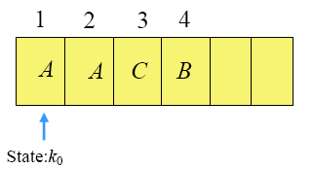
δ( k₂, A) = (k₁, C, L); δ( k₂, C) = (k₁, B, R)
Assume your TM’s initial configuration is as shown below. Show the mapping of the elements of this TM to a protection system. Show all possible transitions, indicating each new TM configuration reached (i.e., state, head position and the symbols in each cell) and its corresponding protection state (the entries in the Access Control Matrix).

- Read the paper by Ravi S. Sandhu, Pierangela Samarati (click the paperlist link) and write a one page summary/critique/review.

